Experiment 9
Compare Linear and Polynomial Regression using Python
Aim
To compare Linear Regression and Polynomial Regression using Python and analyze their prediction performance.

Program
# Compare Linear and Polynomial Regression
import numpy as np
from sklearn.linear_model import LinearRegression
from sklearn.preprocessing import PolynomialFeatures
from sklearn.metrics import mean_squared_error
# Dataset
X = np.array([1,2,3,4,5]).reshape(-1,1)
y = np.array([2,6,7,10,15])
# Linear Regression
lin_model = LinearRegression()
lin_model.fit(X, y)
lin_pred = lin_model.predict(X)
# Polynomial Regression (degree 2)
poly = PolynomialFeatures(degree=2)
X_poly = poly.fit_transform(X)
poly_model = LinearRegression()
poly_model.fit(X_poly, y)
poly_pred = poly_model.predict(X_poly)

# Errors
lin_error = mean_squared_error(y, lin_pred)
poly_error = mean_squared_error(y, poly_pred)
print("Linear Regression Predictions:", lin_pred)
print("Polynomial Regression Predictions:", poly_pred)
print("Linear Regression Error:", lin_error)
print("Polynomial Regression Error:", poly_error)
Output
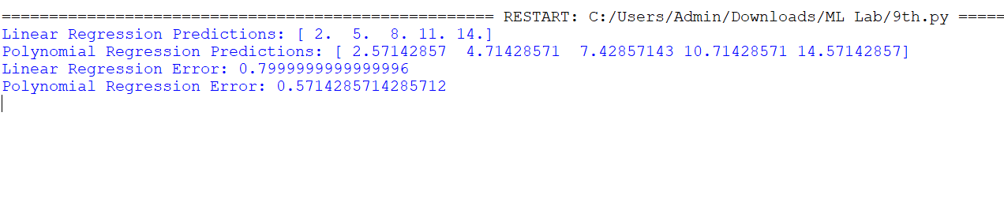

Result
The program successfully compared Linear Regression and Polynomial Regression, and Polynomial Regression produced better predictions with lower error.

